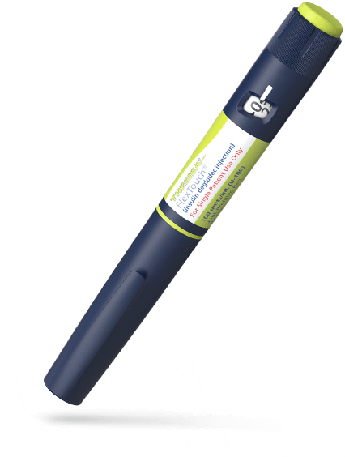
Tresiba® FlexTouch® (Insulin degludec) 100units/ml pens out of stock August 2023 - January 2024
A Medicine Supply Notification has been issued to alert prescribers to a stock shortage of Tresiba® FlexTouch® (Insulin degludec) 100units/ml pens
Summary
- Tresiba® FlexTouch® (Insulin degludec) 100units/ml pens will be out of stock from August 2023 until January 2024.
- Tresiba Penfill® (Insulin degludec) 100units/ml solution for injection 3ml cartridges remain available and can support increased demand.
For full up-to-date information please access Shortage of Tresiba (insulin degludec) FlexTouch 100units/ml solution for injection 3ml pre-filled pens – SPS - Specialist Pharmacy Service – The first stop for professional medicines advice using an nhs.net account
Actions Required for Prescribers
- Do not initiate new patients on Tresiba® FlexTouch® 100units/ml pens during this time
- Consider prescribing Tresiba Penfill® cartridges, which are able to support the market during this time, taking into account the patient’s manual dexterity and ability to use the new device correctly
- When prescribing Tresiba Penfill® 100 units/ml cartridges, ensure that the patient is prescribed a NovoPen 6® with pen needles as per Glucose meters and test strips formulary (GlucoRx Carepoint® 4mm/31G pen needles first line)
- If the above option is not considered suitable, seek advice via advice & guidance or phone/email from the specialist diabetes team on the use of an alternative insulin
Ensure that all patients initiated on a new device are counselled on the change in device, and provided with training on their use, including signposting to resources, as well as the potential need for closer monitoring of blood glucose levels.
Resources
NovoPen® 6 (novonordisk.com) patient information
Novo Nordisk have offered to provide Teams training sessions for appropriate practice staff on the 18th and 26th July 2023 between 12 and 12.30pm. If you have a member of staff who wishes to take part in the training please send their email contact details and the details of the event that they wish to attend to Philip Haydock Philip.haydock@nhs.net. Phil will arrange for invitations to be sent out prior to the event.

The Diabetes Specialist Nurses (DSNs) working within LSCFT have offered to put on a limited number of patient training sessions in August for patients currently under their care. Patients would need to be referred into them using the following email address diabetes.admin@lscft.nhs.uk as soon as possible in order for the DSNs to plan sufficient training. Further details will be circulated to practices if we are able to secure any further training for patients.
To contact the Medicines Optimisation Team please phone 01772 214302
If you have any suggestions for future topics to cover in our prescribing tips please contact Nicola.schaffel@nhs.net
All content accurate and correct on the date of issue of this tip.

